**Exp. 2** **Design Christmas Dual Led Chaser Lights**

Circuit Diagram:

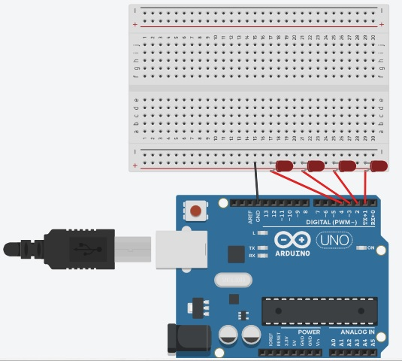

**Theory**

Concepts Used:

1. Worked with Arduino UNO
2. Code with Arduino IDE and syntax
3. Working of LED (Light emitting diodes)
4. For loop syntax and used.
5. Learning to make connections on breadboard

Learning & Observations:

Coding in Arduino IDE: It is a very systematical way to show how the circuits are working. Syntax of coding is very similar to the coding in ‘C’ language which are being taught to us by teacher. What I learnt is that how Arduino can make things interesting

Problems & Troubleshooting

I had very rare problems practicing this as it was very well explained in the class and we had the luxury of our teacher with us

Precaution to be taken

1. Remembered to declared all theory of our e ports in use in digital input/output in the right way.
2. Check whether all your wire pieces are working properly and correctly and all connections are good.
3. TRY to find right amount of delay by approximation.

Learning Outcomes

Overall it was a very exciting practical . I was able to understand the various uses of Arduino board and how can it work in real life,overall how can it help in creating new patents